Application Information
You will search for “UNM” in the search bar. These are the options that should show up.
For the Dual Degree program, You WILL select the “NMNEC UNM-Valencia/UNM Dual Degree Option. Under Main Campus” ONLY FILL THAT APPLICATION OUT IF YOUR ARE APPLYING FOR THE DUAL DEGREE PROGRAM.
Do not fill out the AASN degree application. The reason we say this is there is a question in the application that asks students: if you are not selected for the Dual Degree program, would you like to be considered for our ASN degree program. IF, you select YES main campus will send your application to us to review. If your applying for the our ASN Degree only, then click the ASN degree option. Below is where you will see our programs listed. Select one or the other not both.
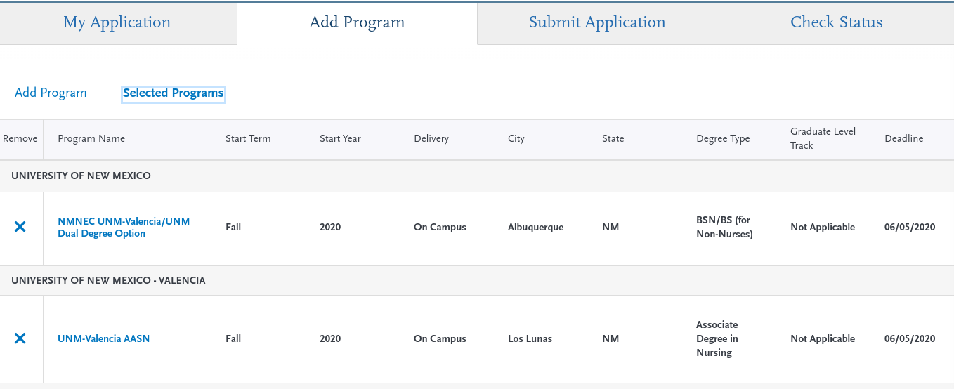

You may begin filling out the application as soon as it is available, and the transcript entry portion may be time consuming.
All applications will be submitted via the online Nursing Central Application System (CAS). The applications must be completed by June 5th, 2020 The link for the application is nursingcas.org
The NursingCAS application is used to apply for the UNM-Valencia AASN and/or the NMNEC UNM-Valencia/UNM Dual Degree BSN Option. This will be a competitive application screening, with 8 available Dual Degree (AASN/BSN) slots and 8 AASN slots. There will be a total of 16 students admitted once per year. The application cycle is during the spring semester and it is for admittance to the fall semester of that year.

Minimum Application Requirements
Complete all required prerequisite classes with a grade of “C” (not “C–“) or better before the application deadline.
Achieve at least a 2.75 grade point average (GPA) in the required prerequisite classes.
Complete the Kaplan Admission Test with a 68% (55th percentile) or higher
Complete the NursingCAS application from March 22-June 5th, 2020 by 9:59 MST.
Send official college transcripts from all institutions attended to NursingCAS at P.O. Box 9201 Watertown, MA 02471 for verification and processing by June 5, 2020. The transcripts must be sent from the registrar, not the student.
Be eligible for admission to UNM. For information regarding eligibility, visit www.unm.edu/apply.
Timeline for Fall 2020 Admission
March 22, 2020: NMNEC UNM-Valencia/UNM Dual Degree Option NursingCAS application period opens.
June 5th, 2020 by 9:59 MST: Fall 2020 NursingCAS application deadline. Meaning that applications must be submitted and paid for by the indicated day and time.
June 5th, 2020: official transcripts must be received, but not verified, by NursingCAS. This is not a postmarked deadline.
July 2020: applicants will be notified of the admission decision by July via the email they used on their application to NursingCAS. All admission decisions are final.
* Applicants offered admission to the UNM-Valencia/UNM Dual Degree students must successfully complete all in-progress classes, before final admission status is complete. This will be verified by submission of an official transcript to UNM CON.
Prior to the Fall 2020 start date: a mandatory NMNEC UNM-Valencia/UNM Dual Degree Option Orientation will be held via an online Zoom Orientation.
Fall 2020: classes start.

Transcript Information
Transcripts must meet the following requirements to be considered “official” by NursingCAS:
The transcript must be sent directly to NursingCAS from the Registrar’s Office of each institution ever attended.
A Registrar’s seal and/or legible signature must be included on the transcript.
The transcript cannot be marked “Issued to Student” or “Student Copy.”
The transcript must reflect all relevant, correct information for the applicant identified on the application.
All questions regarding transcript specifics must be directed to NursingCAS, as they have exclusive access until they are verified.

Nursing CAS Information
All four of these areas must be green prior to application submission.
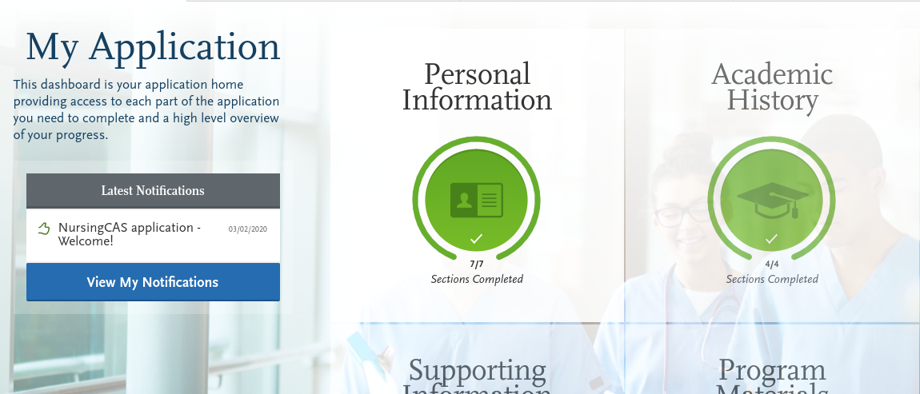

If you are applying to multiple programs: Personal information, academic history, and supporting information will be the same for all programs. The “Program Materials” is program specific and will differ between programs.
Under the “Program Materials” section:

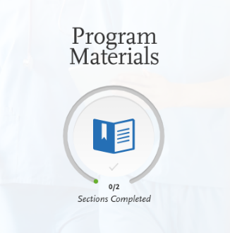

Please go through each tab and answer the questions or upload the required documents.

Under the "Questions" tab in “Program Materials”:
If you are applying for our Dual Degree program there will be a question: if you are not considered for our Dual Degree option, would you like to be considered for our Associates Degree Program? Please answer Yes or No. If you answer Yes and were not selected for the Dual degree, we will get those applicants and go through your application for consideration for our Associates program.

Under the “Documents” tab in “Program Materials”:
If applying for local area residency: Please upload an official document (Utility bill, bank statement, etc)
If applying for veteran status: You will upload a DD-214
If applying for the BSN dual degree: You can upload a document stating that you would like to be considered for the ADN degree track as well as the BSN.
This is also where you will attach you Kaplan score sheet.
The required documents vary between the ADN and the BSN dual degree programs.
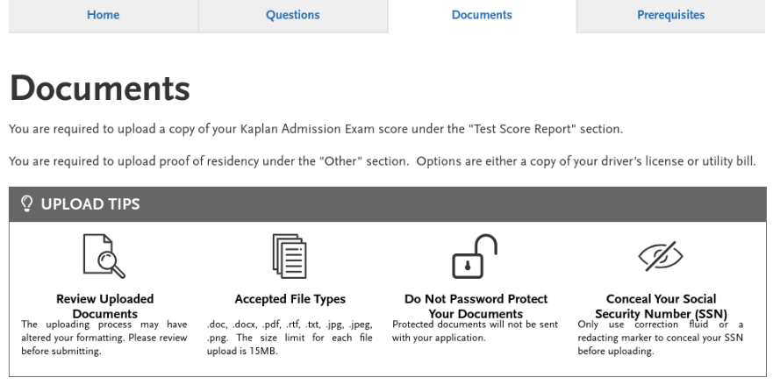
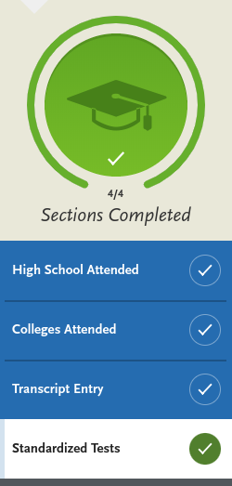
Under the “Academic History” section:
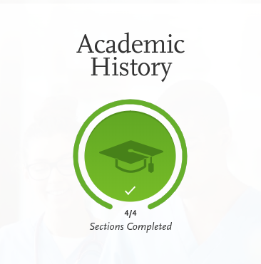

The Kaplan entrance exam is not an option under the standardized tests. You will select the “I am not adding any standardized tests” for this portion or the section will not turn green. You will upload all scores sheets under the “Documents” tab (see above).
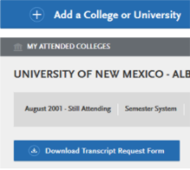
After you have added a College or University, there will be an option to download the transcript request form. This form will assist the registrar in sending the transcripts.

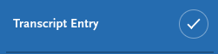

Under the “Transcript Entry” section you must enter all courses ever taken at every institution. This could potentially be a lengthy process. It is recommended you start this portion as soon as possible. Nursing CAS will compare entries to your student profiles and will send back the application if there is any unreported courses or institutions. Enter all courses even if the credits are old, taken during high school (concurrent/dual enrollment), withdrawal, fail, or audited.
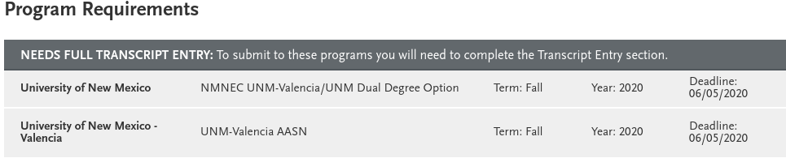

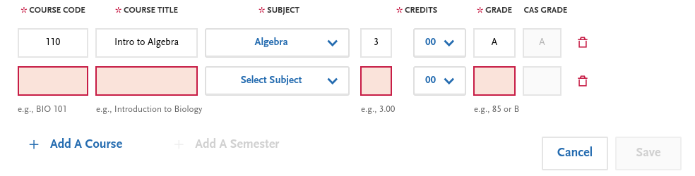
Example on entering your transcripts.

All areas in red must be filled out as it appears on your transcripts.

Sending Transcripts Electronically
Please note that electronic transcripts are not the same as emailed transcripts. We cannot accept transcripts sent via email.
NursingCAS only accepts electronic transcripts from Credentials Solutions, Parchment, and National Student Clearinghouse. If your school does not offer any of these services, your transcript must be sent by mail.
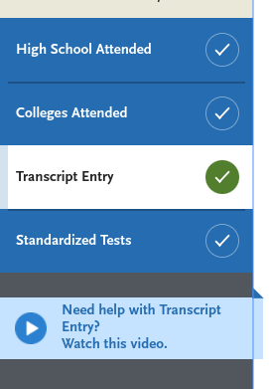
When you are in the “Transcript Entry” portion, there is a tutorial video that may help as well. It is on the far-left side of the screen.
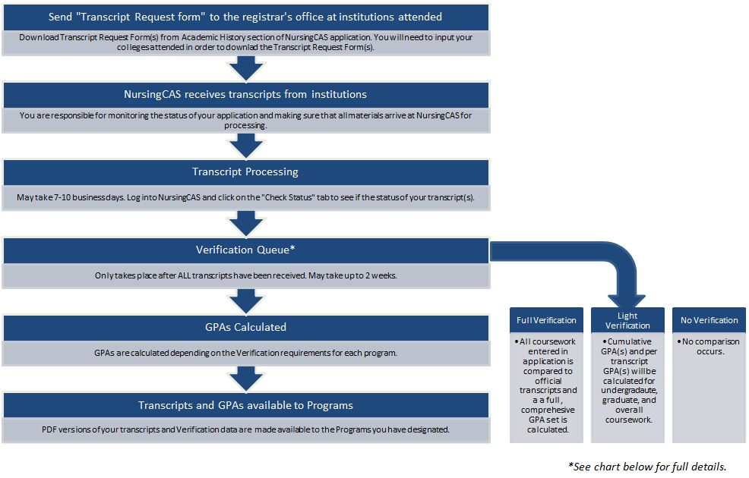

I would highly recommend applicants to NursingCAS Customer Service if you need any help with any questions you may have or help completing your application. Keep checking on your application to make sure your transcripts are all verified and everything is completed before the deadline (June 5th 9:59pm MST) .

Phone Number is 617-612-2880.

Email is NursingCASInfo@NursingCAS.org

https://www.nursingcas.org/resource/help-with-transcripts/
They also have a “Chat” option available where applicants can chat with a live representative. The live chat can be accessed in the NursingCAS Applicant Help Center: https://help.liaisonedu.com/NursingCAS_Applicant_Help_Center
