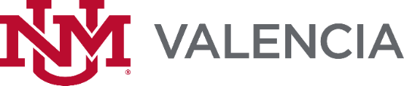
Virtual Freshman Financial Literacy Week
July 12-16, 2021
Hosted by UNM-Valencia Financial Aid Office as part of the Financial Literacy Series
July 12, 2021

10:00 am to 10:30 Welcome Message from the Financial Aid Manager
11:00 am to 12:00 pm Goals & College Identity
1:00 pm to 2:00 pm Navigating LoboWeb & AwardSpring
July 13, 2021

11:00 am to 12:00 pm Career Exploration
1:00 pm to 2:00 pm Student Panel
July 14, 2021

11:00 am to 12:00 pm Budgeting for your First Semester
1:00 pm to 3:00 pm Resource Fair with breakout sessions
July 15, 2021

11:00 am to 12:00 pm Maintaining Your Awards
1:00 pm to 2:00 pm College Identity Part 2
July 16, 2021

11:00 am to 12:00 pm Scholarship Writing Workshop*
1:00 pm to 2:00 pm Scholarship Writing Workshop *
*Student can select the time that works best for them.

